TITLE OF PAPER (Times new roman 14 pt. bold centered)
Author, A¹, Author, B², and Author, C³ (Times new roman 11pt. centered)
¹Institution 1 (Times new roman 11pt. centered)
²Institution 2 (Times new roman 11pt. centered)
³Institution 3 (Times new roman 11pt. centered)
E-mail (corresponding author)
Abstract (Times new roman, 11 pt.): This section is dedicated to the abstract of the paper. The abstract should summarize the paper’s relevance, contributions, and most important results and conclusions. The length of the abstract should not exceed 250 words.

Introduction (headlines: Times new roman bold, 12 pt.)
This is the template for the GNI symposium full paper. The paper length should be maximum 10 pages including references. The main text should be typed using a 11pt Times New Roman font with single spacing and contain a minimum number of defined acronyms. The text of the main body should be justified.

Subsection
Subsections can be added as applicable.

Methods (headlines: Times new roman bold, 12 pt.)
The methodology of the work is described in this section.

Results and discussions (headlines: Times new roman bold, 12 pt.)
The results of the work are shown in this section and discussed. All tables, figures and equations should be centered and numbered. The header for tables should be at the top, while the header for images should be at the bottom.

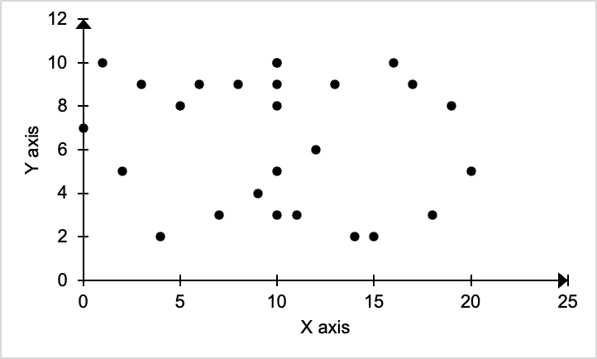
Figure 1. Example figure caption.

Figure 1 shows an example of a figure. The figure should be centered and clear, in color or in grayscale. The figure should include a caption in the bottom of the figure.

Table 1. Example table caption.
Column 1 | Column 2 | Column 3
1 | 4 | C
2 | A | X
3 | a | b

Table 1 shows an example of a Table. Tables are centered and the table caption is at the top of the table.

$f\left(x\right)=a_{0}+\sum_{n=1}^{∞}{\left(a_{n}\cos{\frac{nπx}{L}}+b_{n}\sin{\frac{nπx}{L}}\right)}$ (1)

Equation 1 is an example of an equation. The equation is numbered in parentheses in the same line as the equation to the right.

Conclusions (headlines: Times new roman bold, 12 pt.)
In this section the conclusions of the work are presented. Including limitations, the impact of the work, and future work as applicable.

Acknowledgements (headlines: Times new roman bold, 12 pt.)
In this section authors can express acknowledgements as applicable.

References (headlines: Times new roman bold, 12 pt.)
References should be listed in alphabetical order beginning with the author names. References should be generating using the Harvard referencing style. (Author, et al., 2024)
Author, F., Author, S. & Author, T., 2024. Example of reference style for the extended abstract submisison. GNI Sympossium, 1(1), pp. 1-2.

